

Pain and gain

User Guide



Yasseen Ahmanache Graded unit 2 project

30048974

# User guide

## How to sign up and use the log-in system

### Step 1

Click on the sign-up text on the top right-hand side of the screen which will take you to the sign-up page

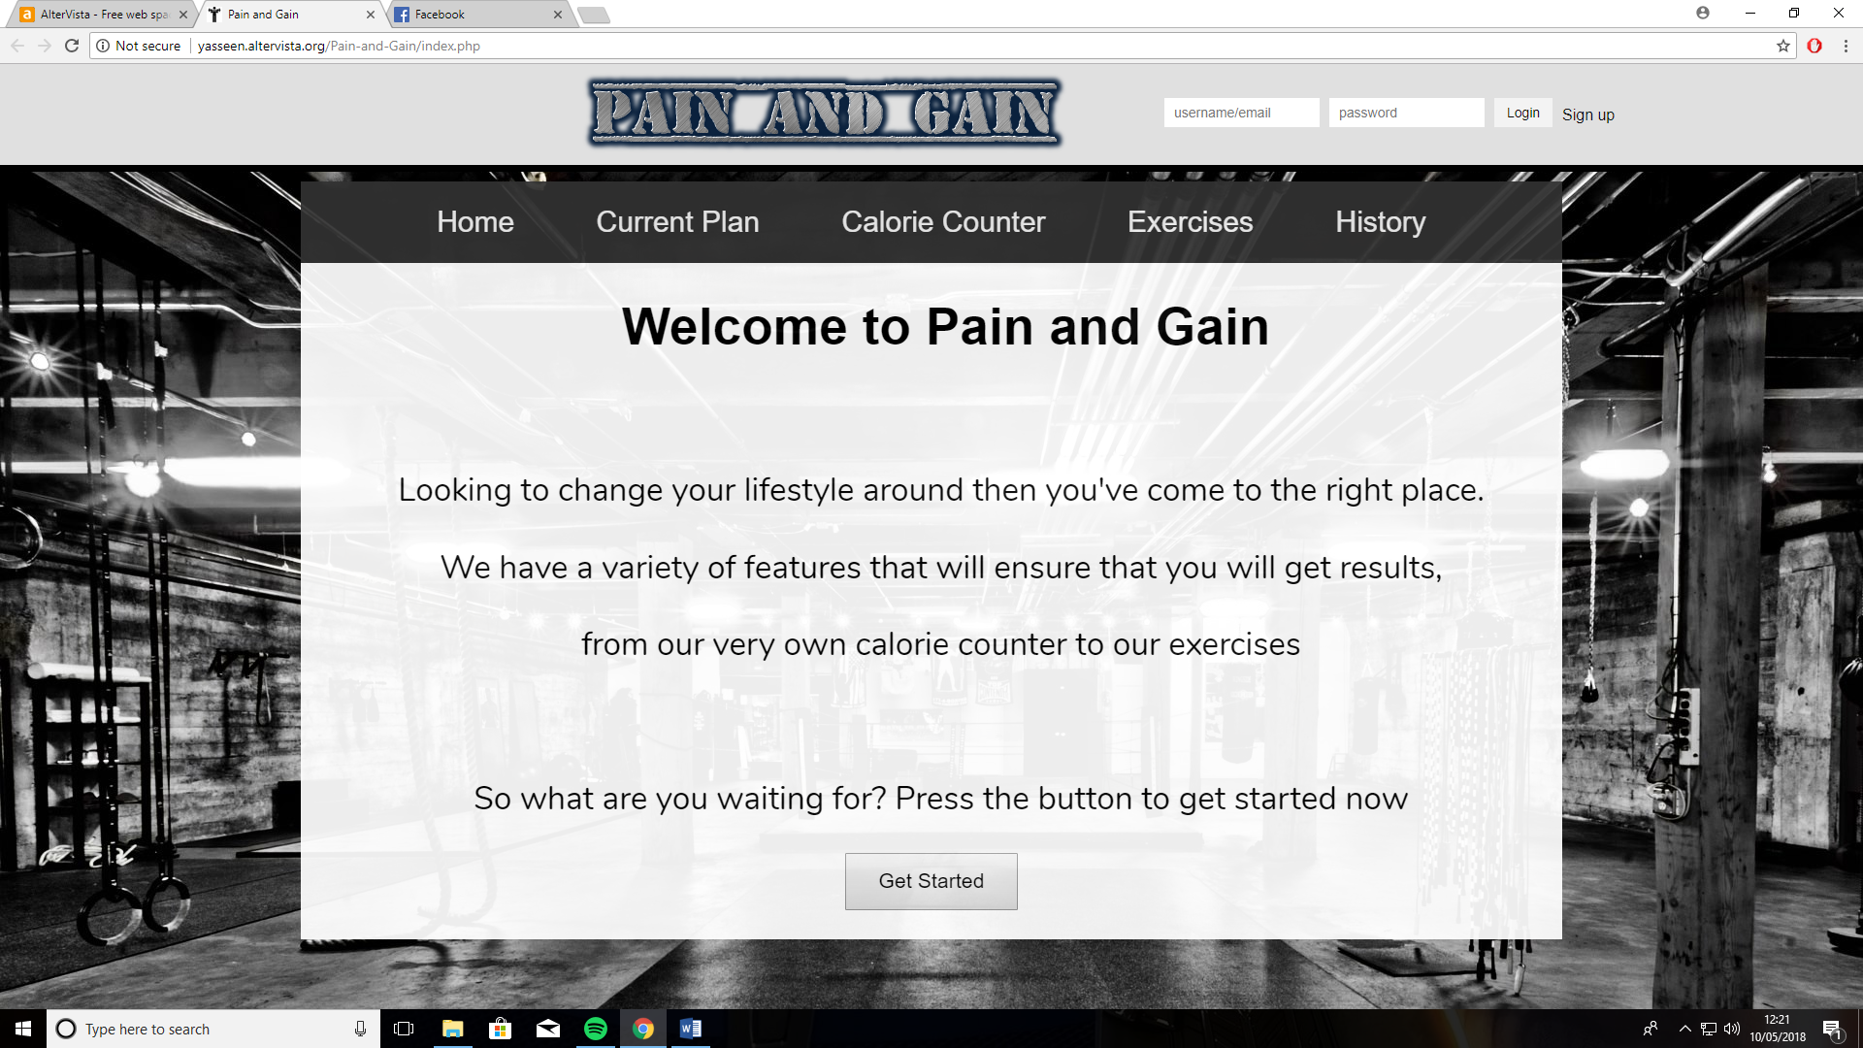

### Step 2

Fill in your details

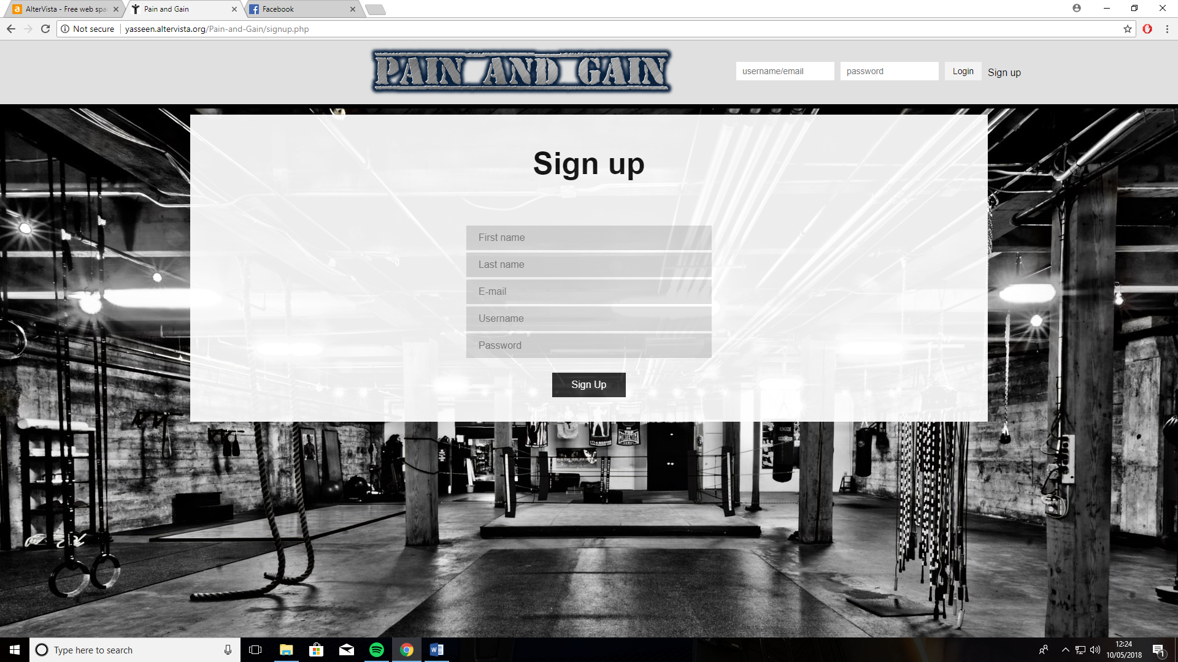

### Step 3

Once you’ve entered in all the fields correctly press the back button and head back to the main page and enter your details in the login section in the top right-hand side and you should log-in straight away if you entered the details correctly.

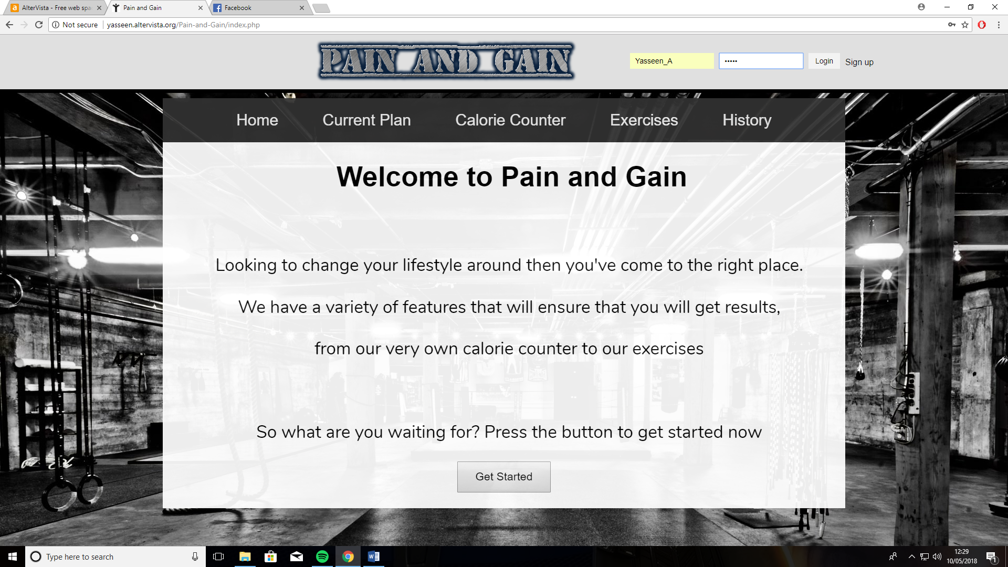

### Step 4

To log out just simply click the log-out button

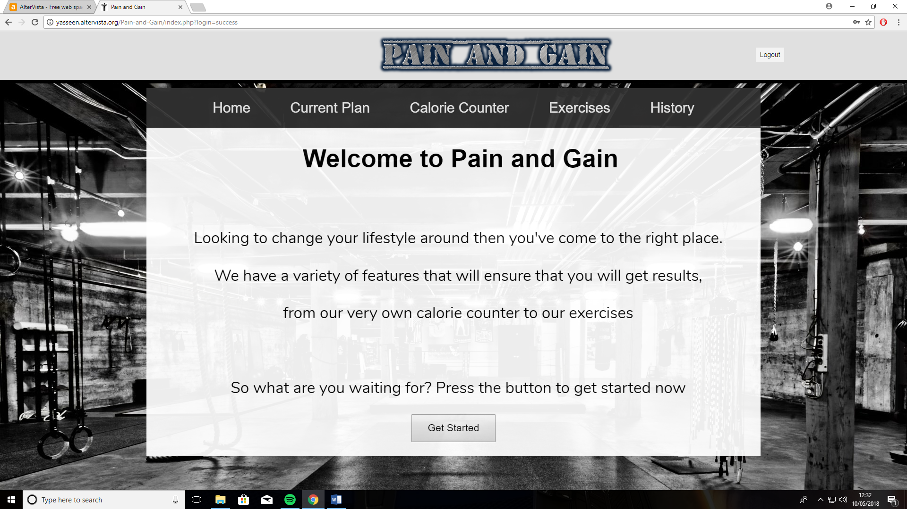

## How to use the calorie counter system

### Step 1

Under the Current Plan page there are two buttons, the one that will display your calorie counter for eating is the one just under the heading “Eating target”. Press that button and you will be greeted with an alert that will allow you to enter your target which then will be displayed right underneath the header.

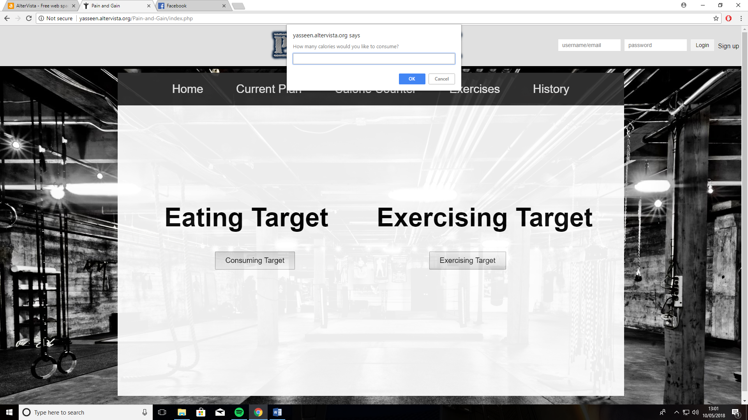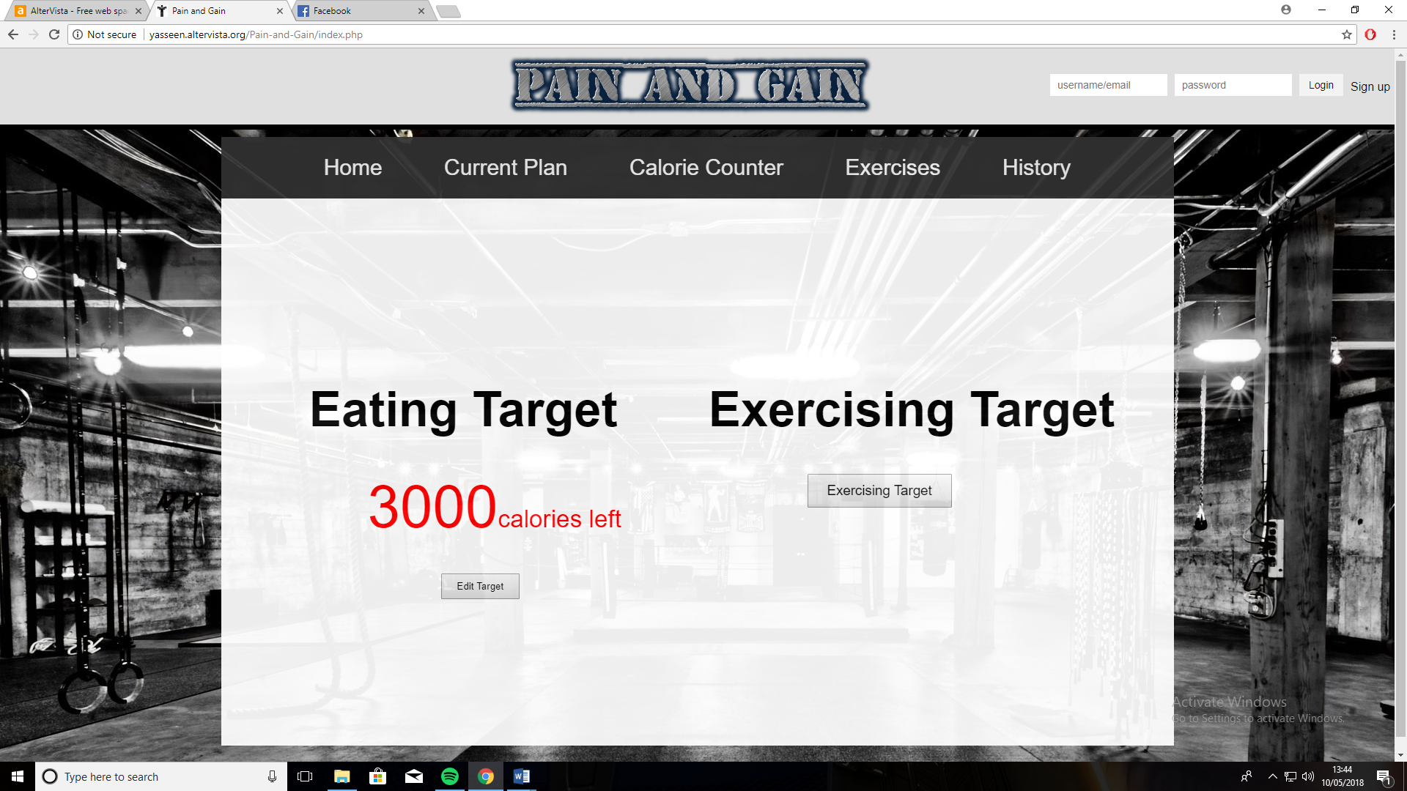

### Step 2

If you made a mistake you can also click on the edit button just underneath your target which will allow you to change the number.

### Step 3

Head over to the calorie counter tab where you will find the drop-down list which contains the list of foods. In this tab you can select a food that you are looking for and add the quantity before clicking the add button which will then calculate the amount you have eaten and deduct it from the target. If, however you have not managed to find your food then you can easily just enter the food name and the amount it contains which will also be deducted from the target.

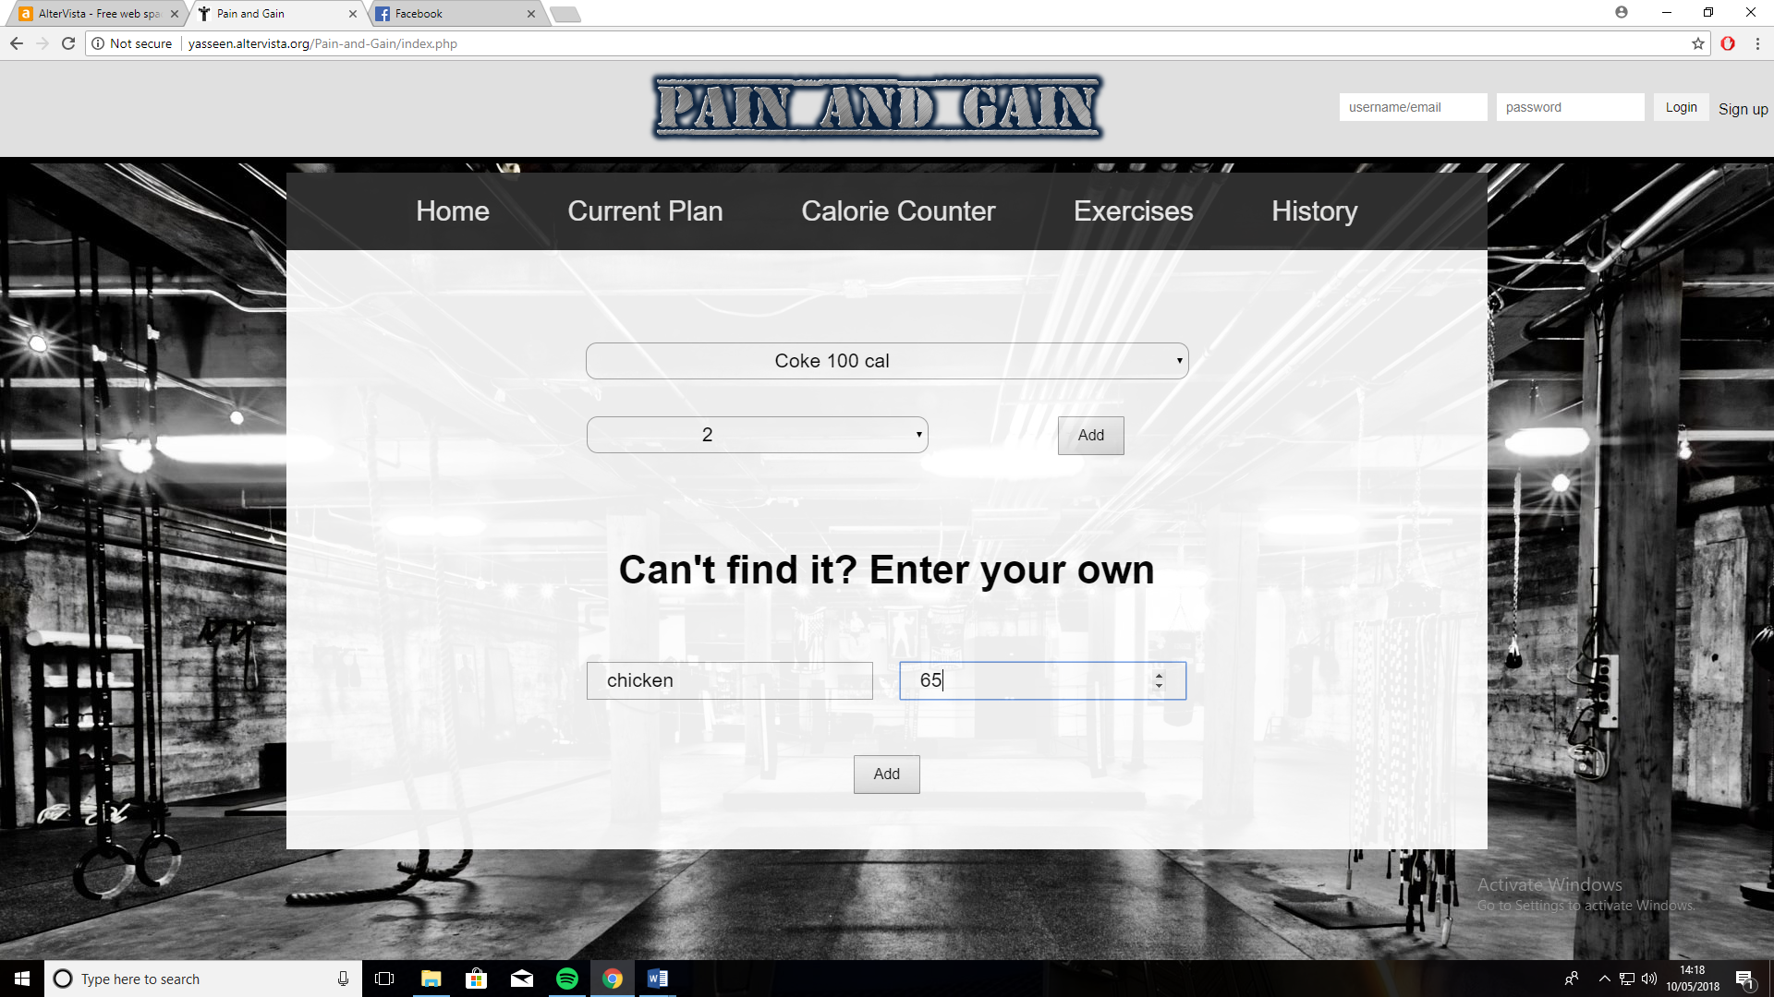

Where to enter your food manually

Where to select your food

## How to use the exercising calorie counter

### Step 1

Like the calorie counter, in the “current plan” page under the heading exercising target there will be a button that will allow you to enter your target for the calories that you want to burn. Press that button and you will be greeted with an alert that will allow you to enter your target which then will be displayed right underneath the header.

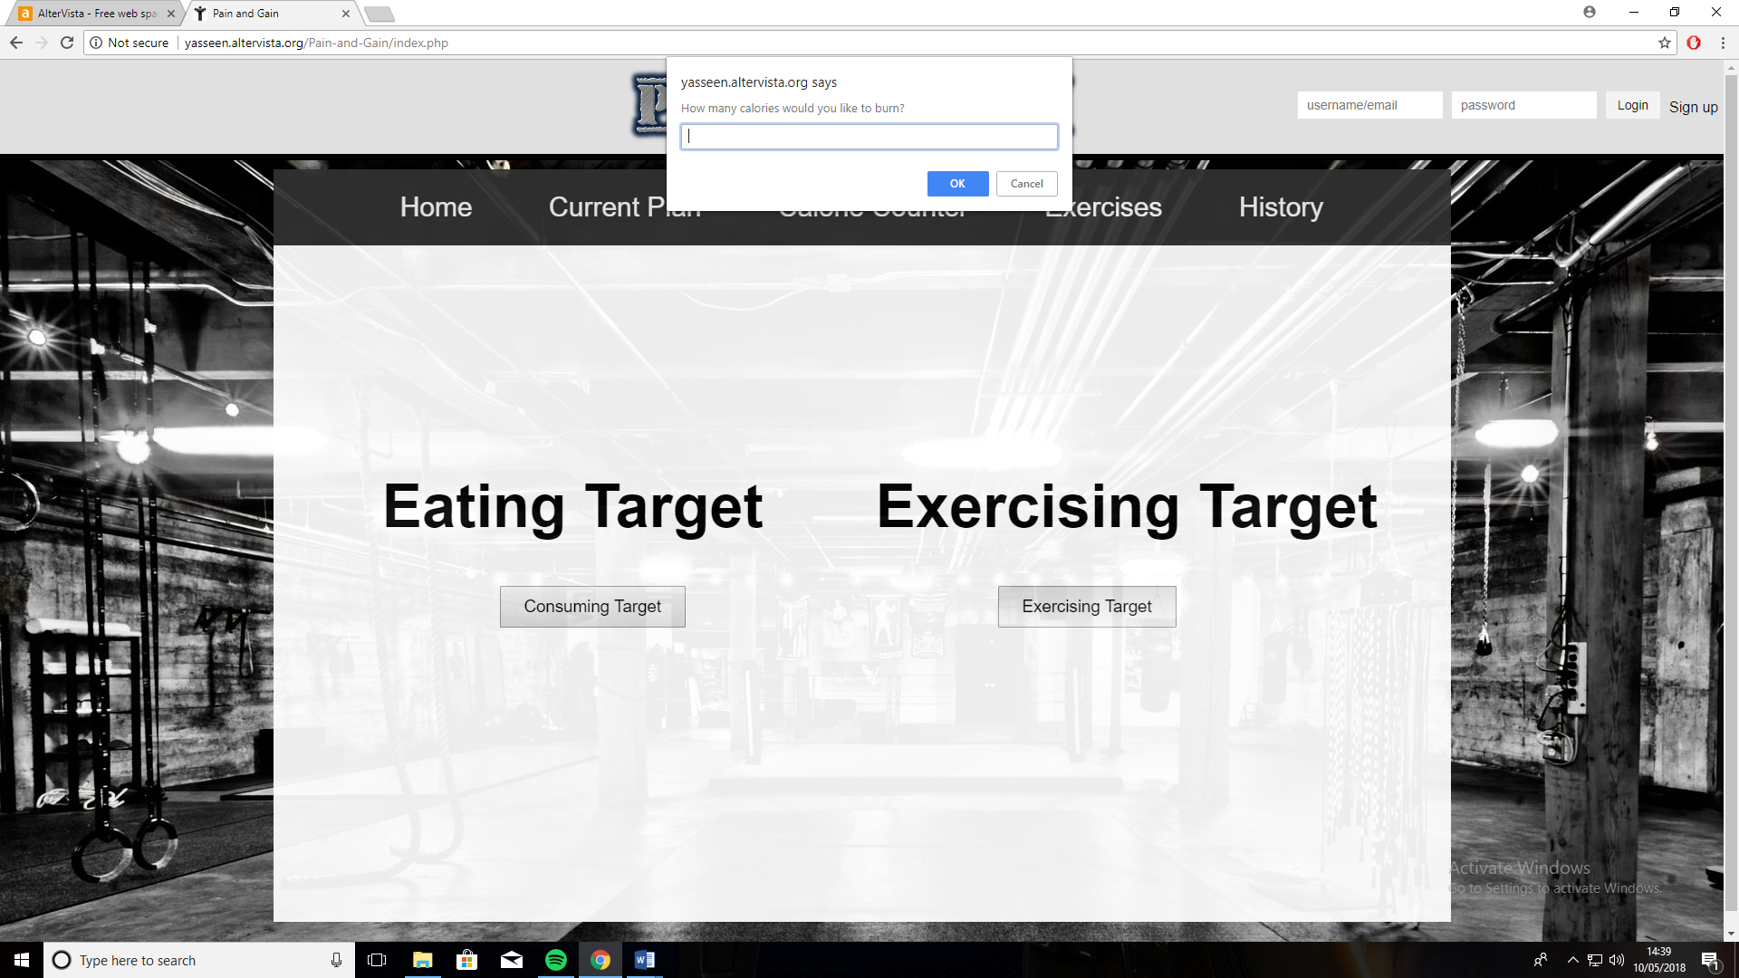 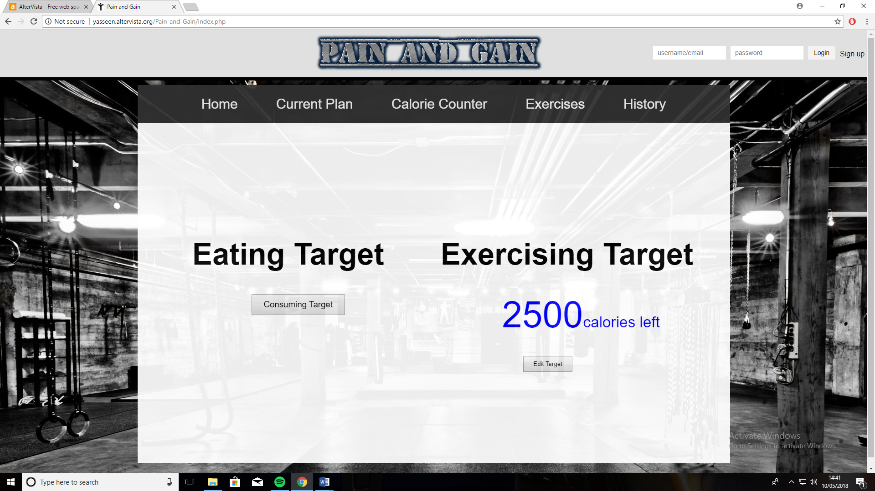

### Step 2

If you made a mistake you can also click on the edit button just underneath your target which will allow you to change the number.

### Step 3

Once you have your calorie counter set for the exercises you can now proceed to exercises tab and choose a body part that you want to exercise on.

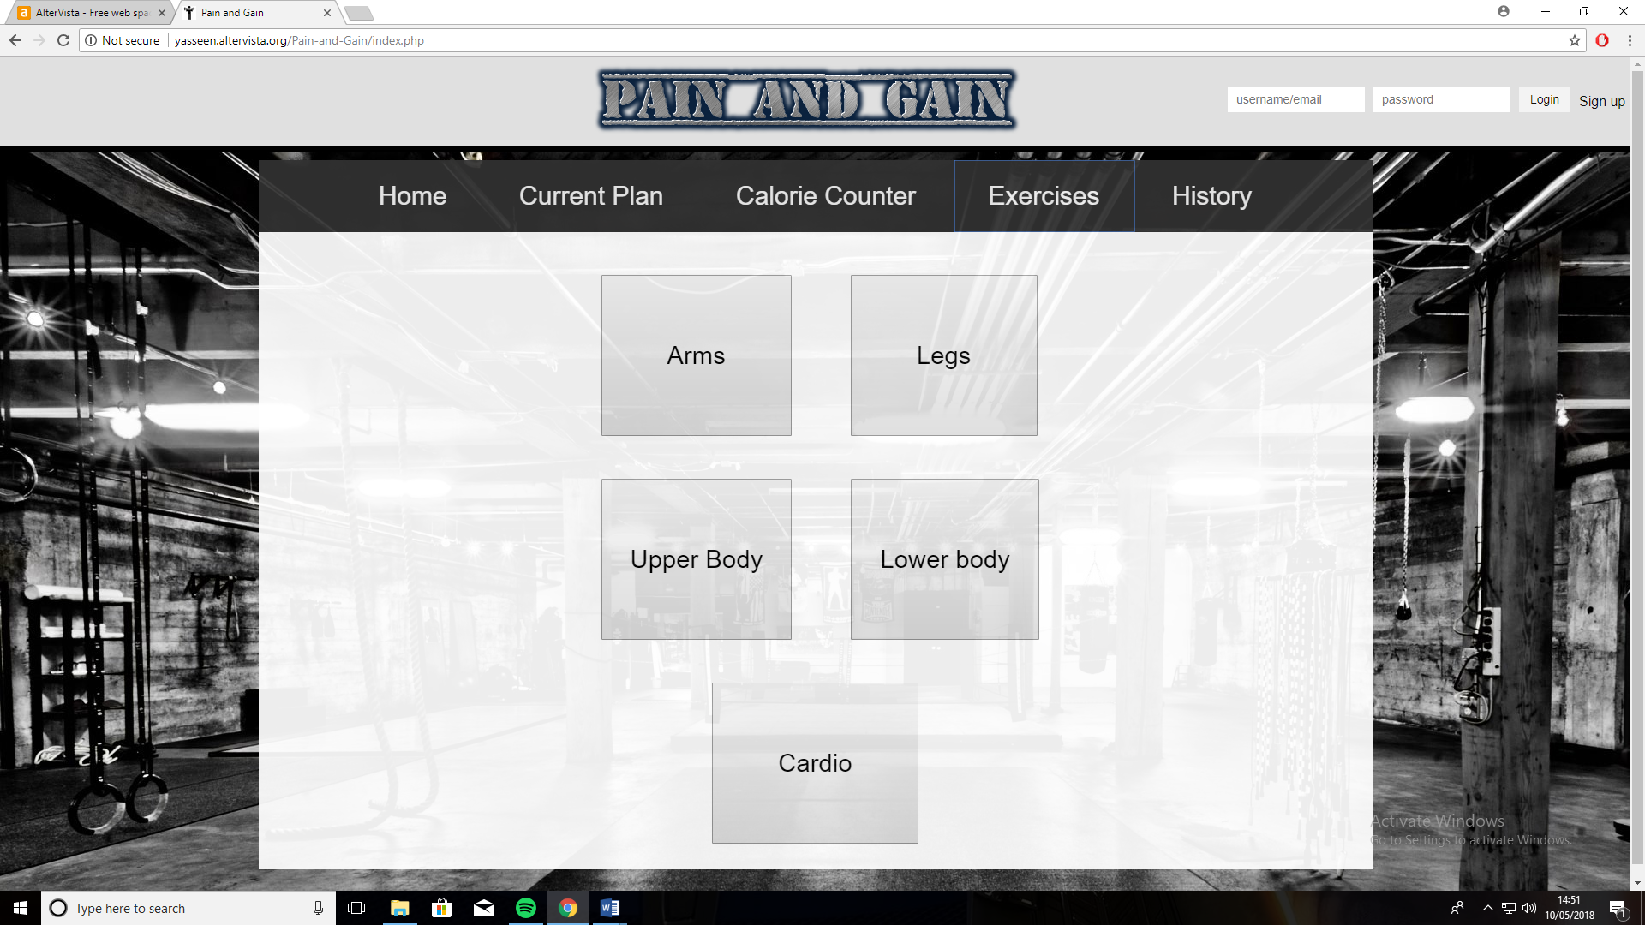

Step 4

Once you have chosen a body part that you want to exercise on, you can now click on it and it will take you over to the page where there are a few exercises that you can perform on them. To add an exercise all you have to do is to enter the amount of sets and reps that you have added for it and then click the add button which will deduct the exercise from the counter.

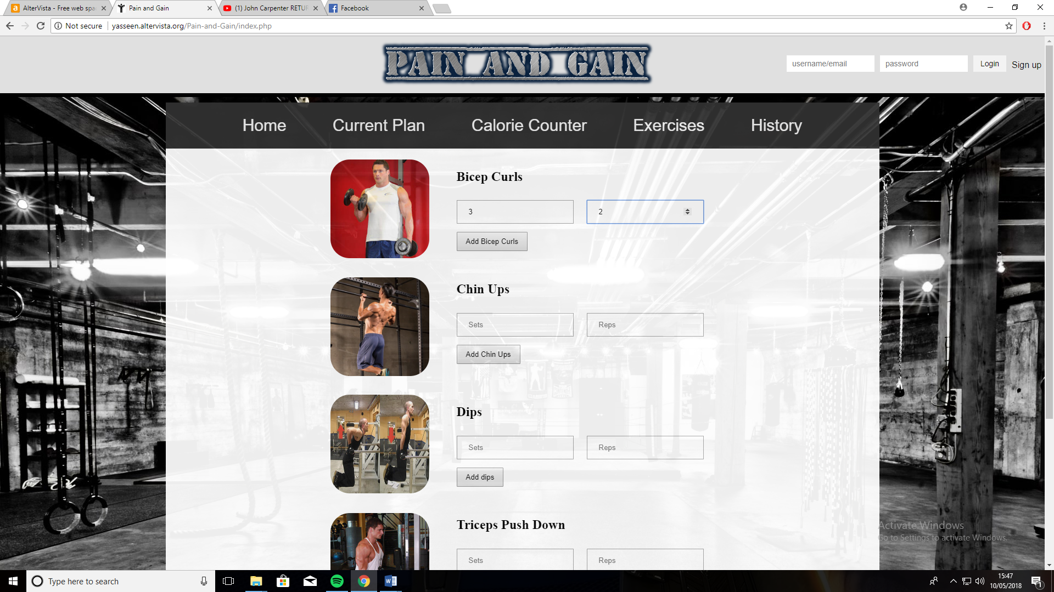

Button to deduct it from the target

Where to enter the sets and reps

## How to use the history tab

### Step 1

In the history tab there is a text area that is completely customisable and will display the exercises that you have performed along with the food that you have eaten for you to be able to save and check later.

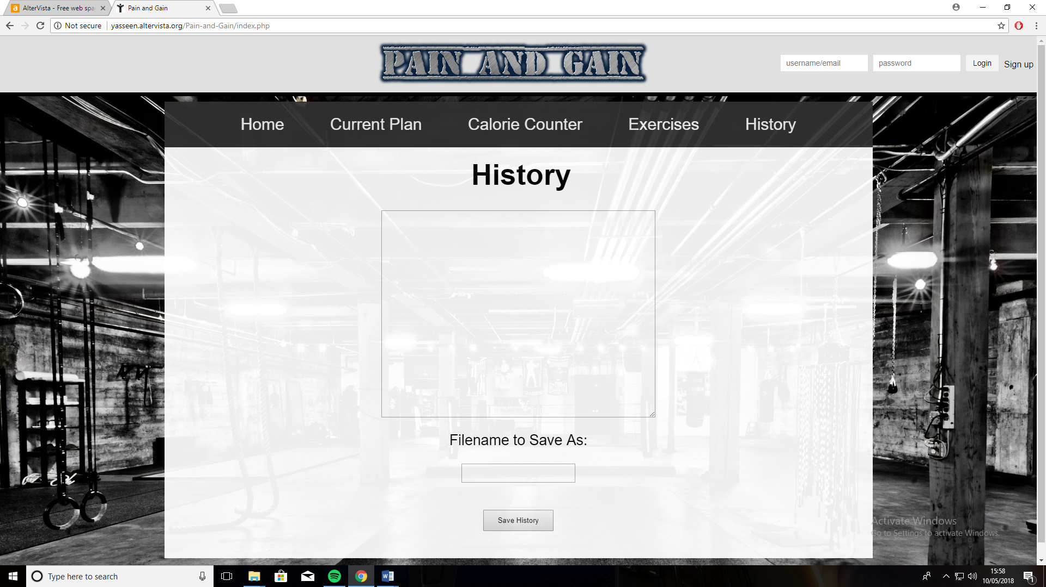

### Step 2

Just underneath the text area, there is an input box which is what you would save your text file as. Once you have entered a name, click on the “save history” button and it will download a text file containing all your foods and exercises.

### Step 3

When opening the text file make sure that you open it up with WordPad over notepad as notepad just takes the text and does not take into consideration the layout.